TIMBER RIDGE RIDE

Saturday, July 14, 2018
50 Mile EC and 25 Mile ERABC Sanctioned Rides

PRE-­‐REGISTRATION IS REQUIRED

DINNER (FRI & SAT) included with ALL ride entries

Send entries and cheques payable to ERABC to: 58 Rangeview Rd, Lumby, V0E2G5or enter online at www.erabc.com/events
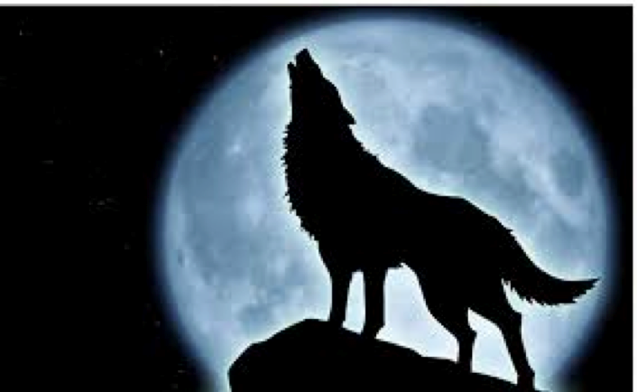
NAME: AGE:

JUNIOR RIDER’S BIRTHDATE: SPONSOR:

ADDRESS: POSTAL CODE:

TELEPHONE #: E-­‐MAIL:

MEMBERSHIP: ERABC # HCBC # EDRA
Copy of card may be required
EC SPORTS LICENCE #: FIRST RIDE: YES ☐ NO ☐
EC sports licence required for 50 mile entry; new licences available on-­‐site for $30 or at www.equinecanada.ca

HORSE’S NAME: AGE: GENDER:

BREED: __________________________ COLOUR: ____________________

Person Responsible:____________________________________Sport License #_________________
Name signature
FEES:

11 Mile Fun Ride - $45 - no deadline ___________

Dinner (Friday and Saturday) included in ALL Ride Entries below. Property rental fees also included.

All fees include $1 Endurance Canada Levy. Fees for 50 mile ride include the $3.50 Equine Canada Medication Control Fee. Junior Riders <17yrs as of Jan. 1st.

25 Mile Ride - $125 Senior, $100 Junior - (deadline July 9) ___________
50 Mile Ride - $160 Senior, $125 Junior - (deadline July 9) ___________
Non-ERABC Member (Residing in B.C.) 25 and 50 mile rides - add $15 ___________
Late entry fee (after July 9 – ‘special’ circumstances only – add $25) ___________
EC Bronze Sport Licence - $30 (available onsite) ___________
Extra Meal Tickets Dinner @ $17.50 pp____ ___________
Would you be interested in purchasing Lunch Saturday if available?( circle one) Yes No
Breakfast Sunday, if available? (circle one) Yes No

Total remitted: __________

TIMBER RIDGE RIDE WAIVER

Please sign the following waiver:

I hereby certify that every horse, rider and/or driver is eligible as entered and agree for myself and my representatives to be bound by the Constitution and Rules of Equine Canada at this competition. It is hereby recognized that all equestrian sports involve inherent risk and that no helmet or protective equipment can protect against all foreseeable injury. I hereby accept this risk and hold harmless EC, the competition, their officials, organizers, agents, employees and their representatives.
______________________________________________________ Date_____________________
(Rider/Junior rider/Owner)

As parent or guardian of the above Junior rider (minor) I understand that I have entered my child in the Timber Ridge Endurance Ride at my own risk and will assume full responsibility for his/her safety and his/her horse’s safety. I have read the above statement and agree that I will hold harmless EC, the competition, their officials, organizers, agents, employees and their representatives. I further confirm that my child has read and understands the above rules. In the event that ____________________ participates in an Equestrian Canada sanctioned competition where protective headgear is required for juniors, he/she will wear properly fitted and fastened approved headgear at all times while riding or driving at the event location. It is understood that juniors not meeting this requirement will not be allowed to compete at these competitions.
______________________________________________ Date______________________
(Parent or Guardian)

The sponsor of a Junior must be a competent adult (21 years or older) and must be duly entered as a competitor in the event and sponsorship must be documented on the Junior entry form complete with sponsor signature at the time sponsorship begins.
Junior and/or sponsor normally may suspend their sponsorship agreement only at regular stated checks and then only with the knowledge and consent of the organizing committee, and OC’s documentation of the change when it occurs.

__________________________________________ Date_____________________
(Sponsor’s signature if different from above)

I agree to comply with all rules and regulations as set out by Equine Canada, Endurance Riders Assoc. of B.C. and ride management.
I will accept all decisions made by veterinarians regarding the horse I am riding. I also understand that I am entering this ride at my own risk and assume full responsibility for my own and my horse’s safety.
I agree I will not hold ride management, ERABC, or their directors responsible for any accident or injury.
I further agree that I will not hold any landowner responsible for any accident or injury. I have read fully the documents attached to this form and agree to the above.

_________________________________________________________ Date ____________________
(Rider and/or Junior Rider)
As parent or guardian of the above minor, I understand that I have entered my child in the Timber Ridge Endurance Ride at my own risk and will assume full responsibility for his/her safety and his/her horse’s safety. I have read the above statement and agree that I will not hold ride management, ERABC, or their directors responsible for any accident or injury. I further confirm that my child has read and understands the above rules.

_________________________________________________________ Date __________________
(Parent or Guardian)

