LET’S TALK ENDURANCE
SPRING TRAINING CAMP
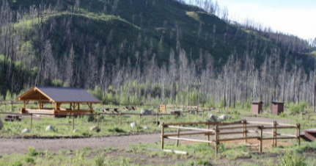
May 21, 22, 23 – Barriere BC

Prepare for the 2022 Endurance season at Fish Trap Creek, near Barriere BC this May Long Weekend.

The camp will offer morning “coffee” and evening “fireside” chats on hot topics including saddle fit, hoof boots, electrolytes, and body work led by local experts and professionals, with an opportunity for everyone to share.

Ride training will be at riders’ discretion. There are 185km of varied trails to explore.

Take this opportunity to get your camping gear sorted, meet with old and new friends, learn and share knowledge and get out riding!

Fish Trap Horse Camp is a user maintained horse campsite 12.5 km from Barriere. There are some corrals but it is first come first serve so be prepared to highline or bring your own pen.
https://hcbc.online/trails?State=ZoneTrail&TrailAlias=167

HIGHLIGHTS:
Dana Johnson (Nicker’s Saddlery and Sensation Ride) will lead a discussion on saddle fit Saturday morning. She will also be offering saddle fit sessions. If you are interested in a fitting, please contact her directly. Email: equeffusion@gmail.com

Gail Jewel (Endurance and Equine Vet with years of Endurance will lead an equine back health and stretching session on Sunday morning.

Christine Westerveld of Stable Balance Equine Therapy will give an “osteopathic adjustment” demo and be available for treatments

